

**UCLA PRODUCERS PROGRAM**

Curriculum and Course Requirements

Class of 2024

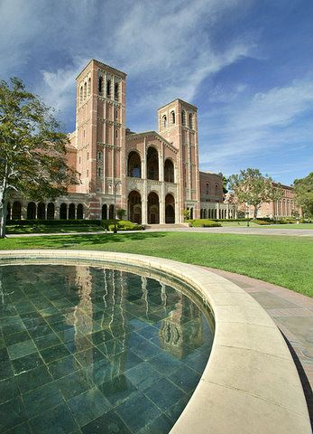

The two year program is designed to give all of our incoming students the essential tools for

PRODUCERS PROGRAM CURRICULUM

**Overview**

The two-year program is designed to give all of our students the essential tools for them to successfully launch and succeed in their chosen careers in production; as producers, studio executives, agents or manager/producers in an array of the most current media, from film to television to digital media.

**The First Year**

The first year is intentionally designed to be an immersive and detailed experience emphasizing the fundamentals of producing. The “Introduction to Producing I-III” series, which is limited to the first-year producing students, represents the backbone of the program. Here, students learn what a producer does and get a detailed overview of how the industry operates. Students also learn the basics of producing: from inception of an idea through development, procuring talent and financing to planning and executing a production to marketing and distribution of the final product. Producers have to be able to conceptualize and oversee the entire life cycle of a creative project, and the PRODUCERS PROGRAM’s curriculum reflects just that.

In addition to “Introduction to Producing” series, students in their first year also take lecture and seminar courses dealing with a variety of topics, including: feature film and television development, studio and network management, production planning/budgeting, entertainment law and business negotiations, international financing and distribution, film festival strategies and the new CMS Common Course taken by all MFA students in the school of Film, Television and Digital Media. Offered by the PRODUCERS PROGRAM, some of these courses are also open to graduate screenwriting, directing, animation and cinema & media studies students, and in certain cases, to law and business students. This way, producing students can meet their classmates from the other TFT programs and start building a professional network in the classroom.

Finally, PRODUCERS PROGRAM students are encouraged to develop and find their own creative projects throughout their first year. In the spring quarter of their first year, students will pitch a slate of at least three projects to a panel of industry professionals. This panel will help contribute to the selection of the student’s thesis project for their second year.

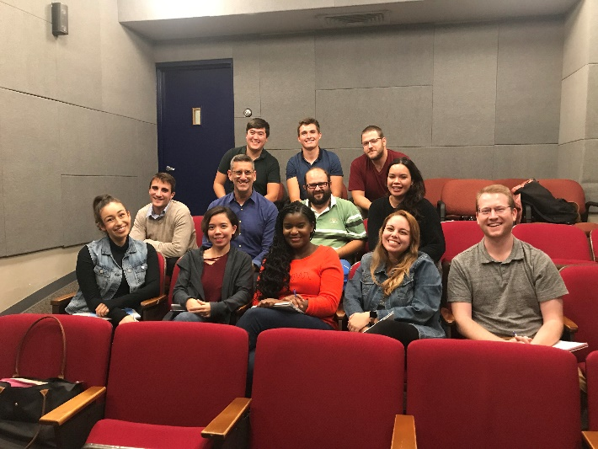**Class of 2020 with Downton Abbey Director Michael Engler**

### The Second Year

In their second year, producing students apply the knowledge they have gained in the first year to a concrete project in the “Thesis Workshop I-III” series. Having optioned a screenplay or teleplay at the end of their first year, students will further develop that project and design a financing strategy that is realistic in the contemporary marketplace. The Thesis Workshop series is exclusive to second-year producing students and continues their work from the “Introduction to Producing” courses. In the Thesis Workshop series, students workshop their thesis projects with their classmates, the instructor, and frequent guests from the industry. This “real-world” feedback helps the students refine their strategies in light of the contemporary marketplace. In addition, the second year includes a deep dive into digital media with the digital media series I & II classes.

Students also may take courses that take a comprehensive look into the independent film world, what it is like to be a showrunner for a television series, feature film marketing, how to develop television projects from IP, intellectual property and film festival strategies. In addition, students are required to take one course in any of the other areas within the Department of Film, Television and Digital Media; that is in screenwriting, directing, production, animation, or digital media. Thus, the students broaden their perspective and understanding of the entire media production process.

Producing students usually elect to complete their Secondary Thesis Production Experience by producing an M.F.A. directing student’s thesis film in their second year. This experience typically involves a follow up collaboration between a directing student and the producing student who had worked with them in their collaboration course during the winter quarter of their first year.

### Thesis Requirements

PRODUCERS PROGRAM students complete a two-part thesis that culminates their requirements in the Program. The thesis consists of a professional-length feature or television project that the student intends to produce upon completion of the Program and a production experience – typically a short film produced while enrolled in the Program.

A feature project consists of an optioned screenplay that the student will further develop with the screenwriter and a comprehensive strategy that discusses how to package, finance, budget, market and distribute the project. A television project consists of a teleplay for a pilot that may be optioned or an original (requires petition and writing sample(s) for permission from the faculty) and a comprehensive strategy that discusses how to package, finance, budget, market and distribute the project.

A thesis committee comprised of one faculty member and two industry professionals supervises the student. The thesis committee works closely with the student on his or her project, advising them on their strategy and reviewing and giving feedback on the student’s thesis binder in two separate rounds.

The second part is a production experience. Typically, the producing student will collaborate with an M.F.A. directing student and produce their thesis film. The student assists the director in realizing their creative vision and manages physical production.

Finally, the student must participate in an oral panel presentation of his or her project before a panel of industry professionals and faculty in mid-March during the Thesis Workshop II class.

### Course Requirements

The PRODUCERS PROGRAM has the following time-to-degree requirement: six quarters. The minimum number of units is 82 and there are at least 18 required courses.

## Core I

PRODUCERS PROGRAM students enroll in the following 18 core classes in their first and   
second years.

## Year 1

|  |  |  |  |
| --- | --- | --- | --- |
| Curriculum | Fall | Winter | Spring |
| ***Producing*** | 287A Introduction to Art and Business of Producing 1 | 287B Introduction to Art and Business of Producing 2 | 287C Introduction to Art and Business of Producing 3 |
| ***Television Development*** | 282A: TV Development 1 | 282B TV Development 2 |  |
| ***Production / Financing*** |  | C247 Physical Production for Creatives | 294A Entertainment Law & Business Practices  294C International Finance and Distribution |
| ***Feature Development*** | 288A Feature Film Development 1 | 288B Feature Film Development 2 |  |
| ***CMS*** | CMS Common Course |  |  |

## Year 2

|  |  |  |  |
| --- | --- | --- | --- |
| Curriculum | Fall | Winter | Spring |
| ***Primary Thesis*** | 290A Thesis Workshop 1 | 290B Thesis Workshop 2 | 290C It’s a Wrap: Final Preparation for your Entertainment Career |
| ***Digital Media*** | 297A Digital Media Producing 1 | 297B Digital Media Producing 2 |  |
| ***Other required courses*** | Required course outside of Producers Program in another MFA Area | CMS Seminar Class |  |

## Core II

Students enroll in 5 courses selected from the list below and 2 sections of the internship course, FTV 498. Courses may be taken at any point in Year 1 and/or Year 2, depending on availability.

|  |
| --- |
| **Core II** |
| 282A Overview of Network Television Management |
| 289C Independent Spirit: Creative Strategies for Financing and Distributing Independent Features |
| 291A Studios versus Independents: Navigation Process |
| 291B Feature Film Marketing |
| 291C Feature Film Distribution and Exhibition |
| 292A Overview of Network Television Management |
| 292B Advanced TV Development Workshop: Reverse-Engineering Intellectual Property for TV |
| 292C Producing for Broadcast and Cable |
| 295B Advanced Film and Television Producing Workshop |
| 295C Advanced Producing: Role of the Successful Producer |
| 296A Role of Talent Agencies |
| 296B Who Represents Me? |
| 298A Planning the Independent Short Film |
| 298A Career Strategies in Producing |
| 298A Film and TV Writing for Producers |
| 440 Film Festival Strategies |
| Theater C446A Entertainment Design 1 (“Imagineering” 1) |
| Theater C446B Entertainment Design 2 (“Imagineering” 2) – prerequisite: C446A |
| Theater C446C Entertainment Design 3 (“Imagineering” 3) – prerequisite: C446A & C446B |

## Outside MFA Requirement

Students enroll in 1 course in an MFA area outside the PRODUCERS PROGRAM (i.e. Screenwriting, Directing/Production or Animation). All Producers Program students who wish to enroll in a Screenwriting class must first take FTV 430, Introduction to Film/TV Writing, offered only FALL QUARTER.

|  |  |
| --- | --- |
| **Production/Directing** |  |
| 403A Advanced Documentary Workshop | Check registrar’s schedule |
| 418 Advanced Coverage | Check registrar’s schedule |
| 476 Production for Non-Production Majors (or equivalent, as designated by Production/Directing) | Check registrar’s schedule |
| **Screenwriting** |  |
| 283B Writing the TV Comedy Script | Check registrar’s schedule |
| 283C Running the TV Comedy Room | Check registrar’s schedule |
| 284B Writing the TV Drama Script | Check registrar’s schedule |
| 284C Running the TV Drama Room | Check registrar’s schedule |
| 430 Screenwriting Fundamentals | Fall Only |
| 434 Advanced Screenwriting (Prerequisite: 430) | Check registrar’s schedule |
| **Animation** |  |
| C481A Introduction to Animation | Fall, Spring |
| C481B Writing for Animation | Fall only – no prerequisite required |
| C481C Animation Workshop | Winter, Spring – prerequisite C481A |
|  |  |

## Cinema and Media Studies Requirement

Students enroll in a minimum of 2 graduate-level Cinema & Media Studies courses. In the Fall of year 1, all MFA students will take FTV210: CMS Common Course. Please see list below for additional course numbers and titles of CMS classes that students can take for their second CMS requirement.

Please note that not all courses are offered every quarter. Students should consult the registrar’s schedule for available courses and class times.

**Cinema & Media Studies Courses:**

|  |  |
| --- | --- |
| **201A** | SEMINAR: MEDIA INDUSTRIES AND CULTURES OF PRODUCTION -- FOUNDATIONS |
| **201B** | SEMINAR: MEDIA INDUSTRIES AND CULTURES OF PRODUCTION -- TRANSMEDIA |
| **202** | SEMINAR: MEDIA AUDIENCES AND CULTURES OF CONSUMPTION |
| **203** | SEMINAR: FILM AND OTHER ARTS |
| **204** | SEMINAR: VISUAL ANALYSIS |
| **205** | SEMINAR: VIDEOGRAPHIC SCHOLARSHIP |
| **206A** | SEMINAR: EUROPEAN FILM HISTORY |
| **206B** | SEMINAR: SELECTED TOPICS IN AMERICAN FILM HISTORY |
| **206C** | SEMINAR: AMERICAN FILM HISTORY |
| **206D** | SEMINAR: SILENT FILM |
| **207** | EXPERIMENTAL MEDIA |
| **208A** | SEMINAR: FILM STRUCTURE |
| **208B** | SEMINAR: CLASSICAL FILM THEORY |
| **208C** | SEMINAR: CONTEMPORARY FILM THEORY |
| **209A** | SEMINAR: DOCUMENTARY FILM |
| **209D** | SEMINAR: ANIMATED FILM |
| **216** | FILM, COSTUME, AND CHARACTER |
| **217A** | SEMINAR: AMERICAN TELEVISION HISTORY |
| **217B** | SEMINAR: SELECTED TOPICS IN TELEVISION HISTORY |
| **218** | SEMINAR: CULTURE, MEDIA, AND SOCIETY |
| **219** | SEMINAR: FILM AND SOCIETY |
| **220** | SEMINAR: TELEVISION AND SOCIETY |
| **221** | SEMINAR: FILM AUTHORS |

Some courses are taught as a core course for M.A. CMS students and may not be available that particular quarter for MFA students.

1. ***Internships***

Producers Program students must complete at least 2 internships during their time in the program. However, students are encouraged to begin interning in the latter half of their first year and to pursue additional internships during their time at UCLA in order to gain valuable experience in different areas of the Entertainment business.